Convert Excel File to Xml in Asp.net Core

Step 1:

Create a Asp.net Core Web app in a MVC Pattern.

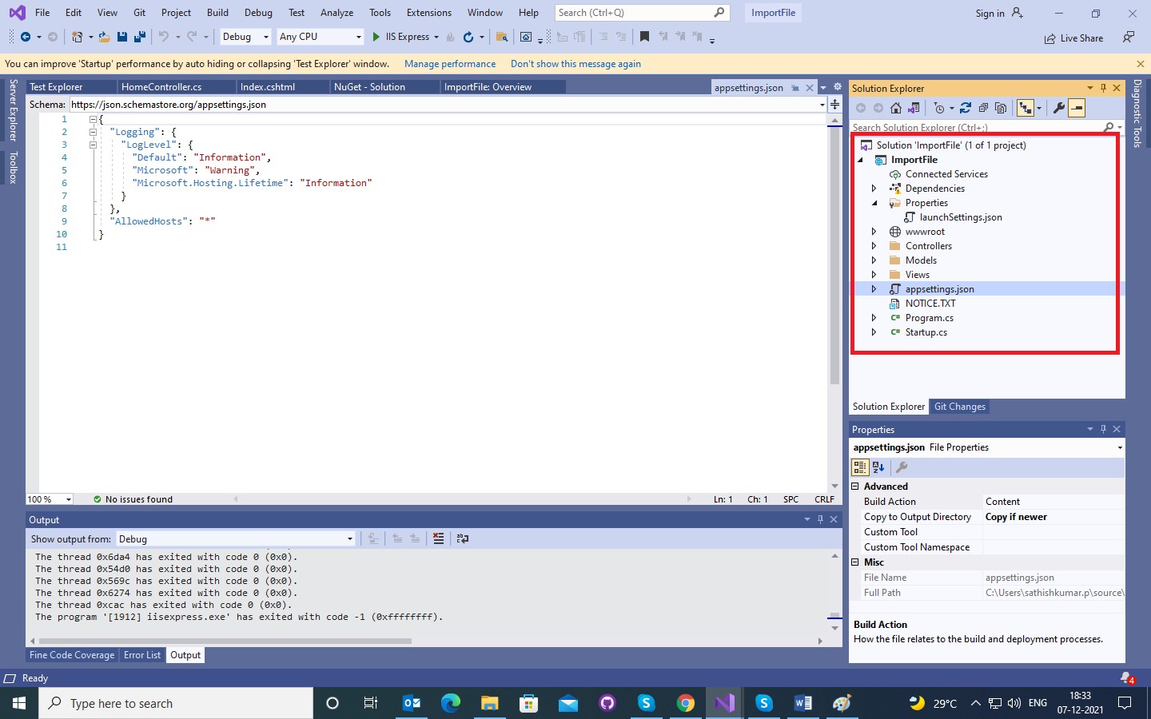

Step 2: Install the Nuget Package DotNetCore.NPOI

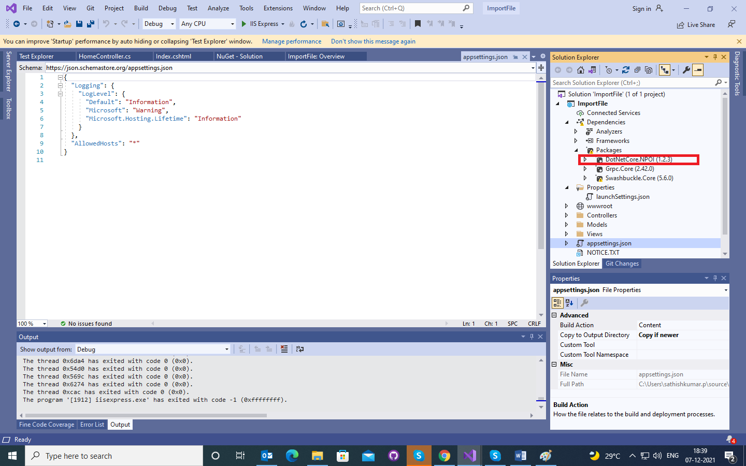

Step 3: Worked on the Home Controller add two method Import and Convert

Step 4: Data is converted as a byte and pass to the convert method.

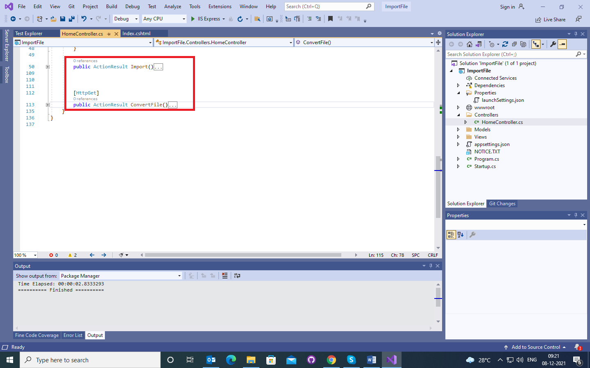

Step 5: Automatic Upload Folder will be created once the file is uploaded.

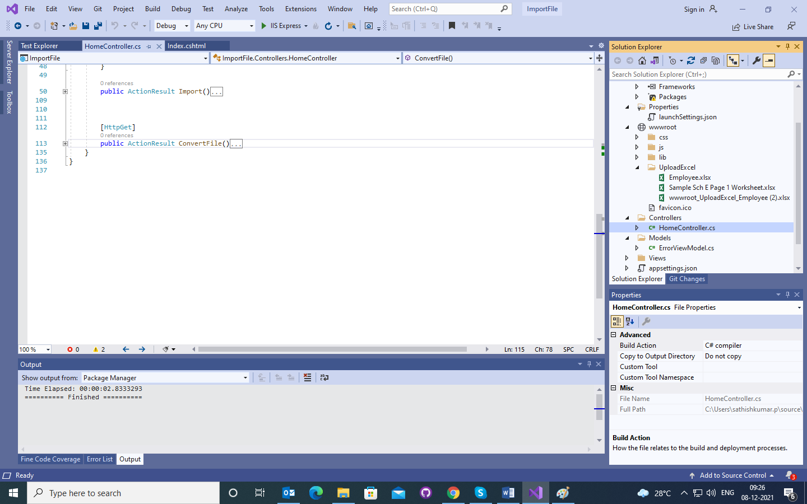

Step 6: File is Converted and download as a XML also done

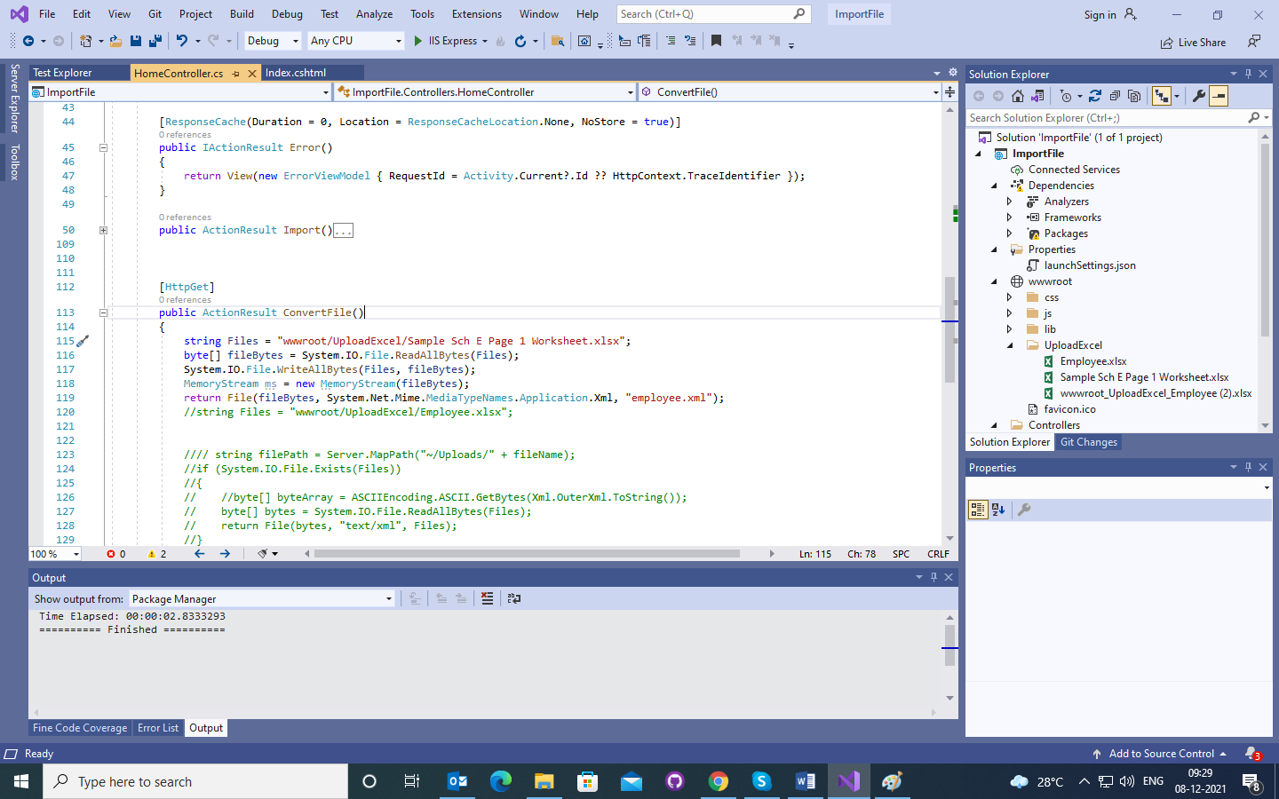

Step 7: Download XML File is empty conversation is problem